<https://github.com/boboppie/coursera-course-statistics_one>

**LECTURE 10– Mediation**

Mediation vs moderation:

* X predictor variable (independent variable - IV)
* Y outcome variable (dependent variable – DV)
* Mediation (M): look at 2 variables, find M that mediates the correlation
  + Mediation variable - M
* Moderation (Z): influence and control on the relationships
  + Moderator variable - Z

**Segment 1: Regression approach**

Mediation: we know there is a relationship! But we want to know more and why this correlation exists.

* Y = B0 + B1X +e 🡨 simple regression (X🡪Y)
* Y = B0 + B1M+e & M = B0 + B1X +e (X 🡪 M 🡪 Y)
  + **Y = B0 + B1M + B2X +e**  🡪 will B2 will be significant? No, if there is Mediation

Implement mediation

* 1. lm (Y ~X)
* 2. lm (M~X)
* 3. lm (Y ~X + M)
  + For full mediation, in 1 and 2, X’s regression coefficient should be significant.
  + And in 3 M’s regression coefficient should be significant, not the regression coefficient for X. If X’s regression coefficient is not significant then full mediation (X approaching to 0). If X’s regression coefficient is still significant then partial mediation.

X is extra, Y is happy, M is diverse. M partially mediates pass from 0.28to 0.22. If M drops to 0 then full mediation.

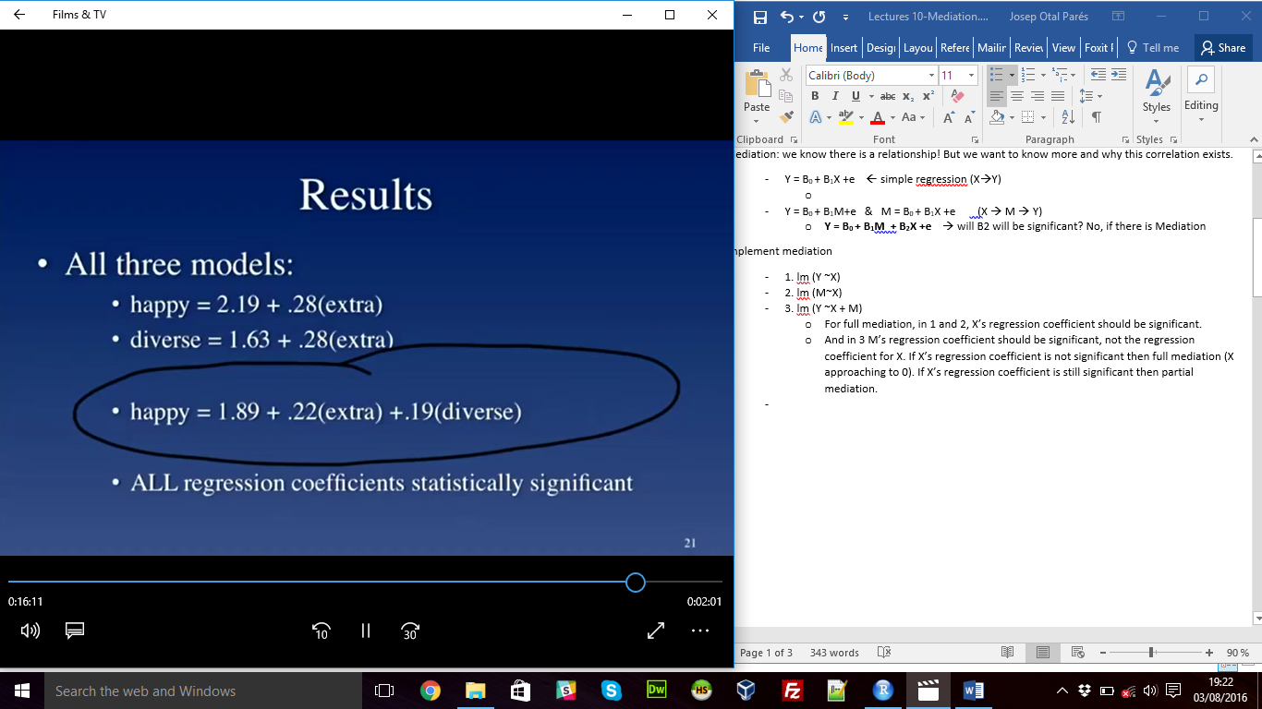

**Segment 2: Mediation: path analysis**

* Path models, to illustatre the model:
  + Rectangles: observed variables (X,Y,M)
  + Circles: unobserved varaibles (e)
  + Triangles: constants
  + Arrows: associations

X: exogenous variable

Y: endogenous variable

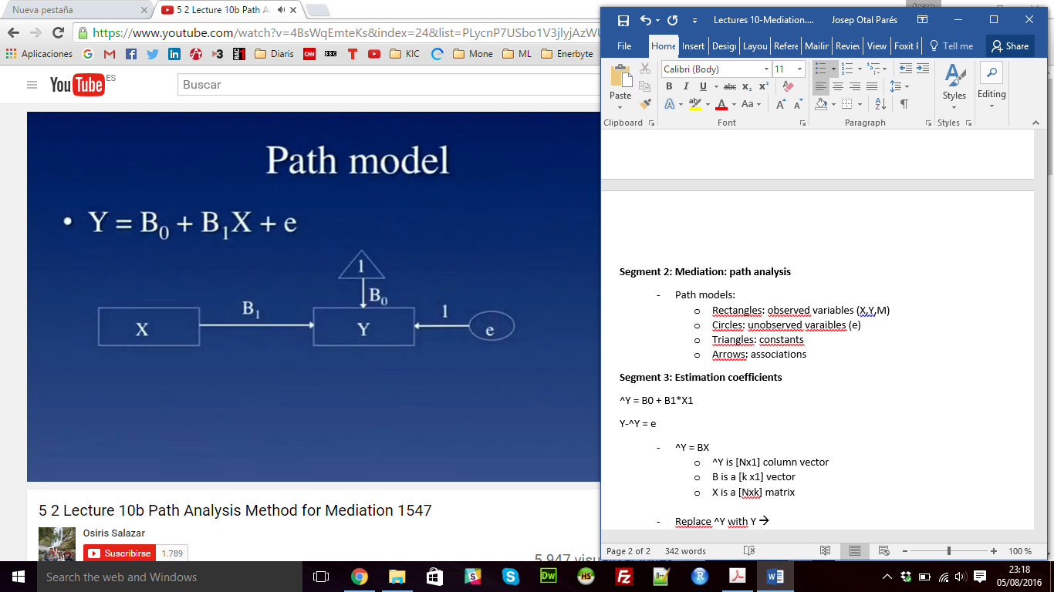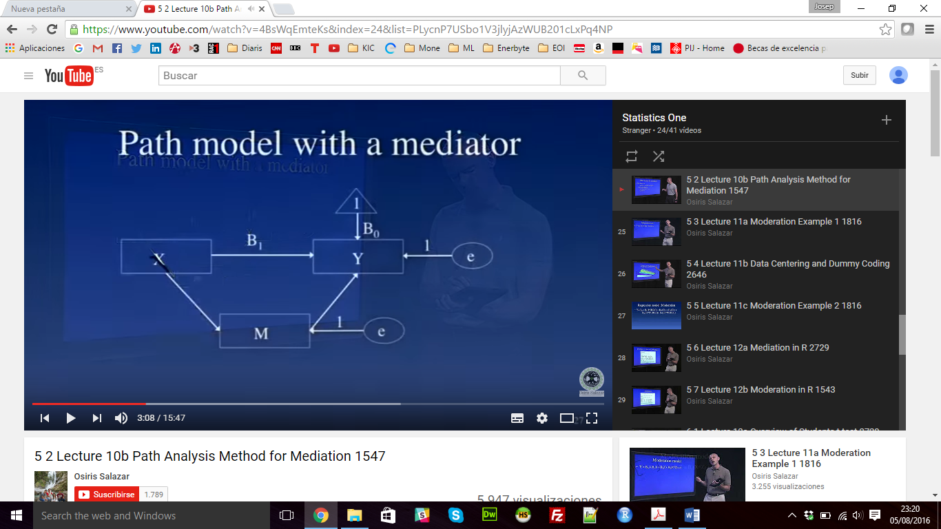

Labelling the path:

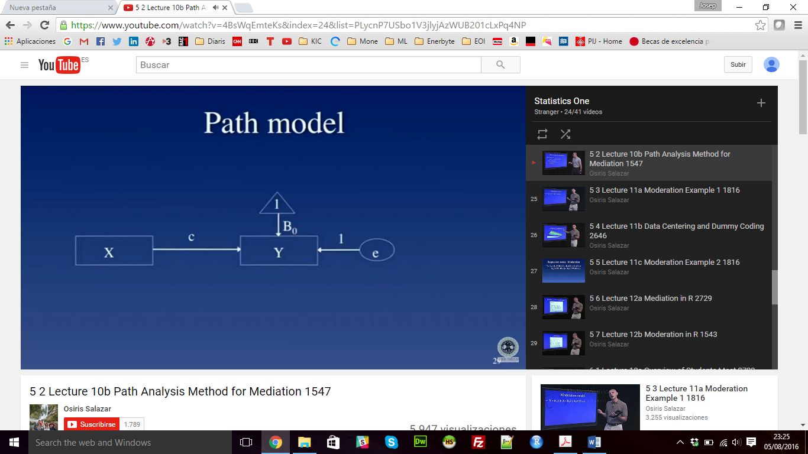 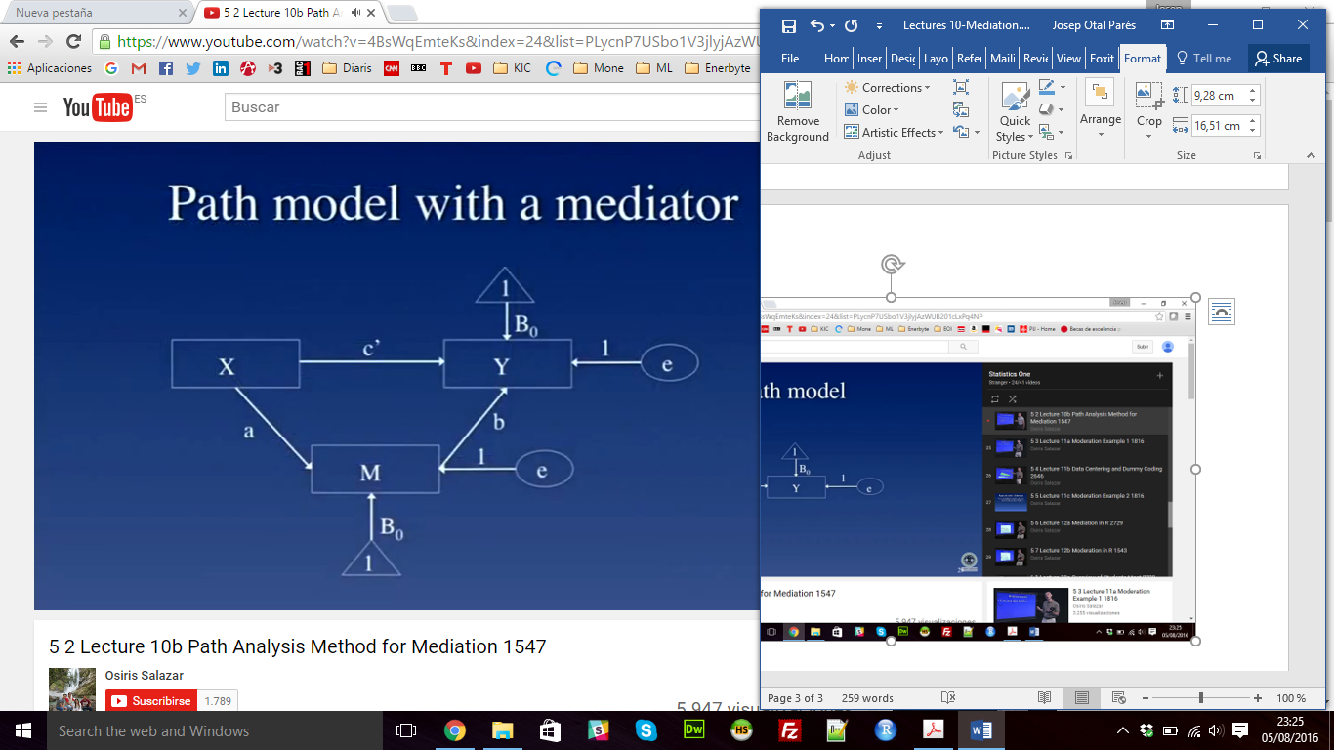

Y = B0 + B1X +e 🡪 Y = B0 + cX +e

**Y = B0 + B1M + B2X +e 🡪 Y = B0 + bM + c’X +e**

M = B0 + aX +e

* “Sobel” test:
  + Test that the indirect effect is 0 (as Null hypotesis)
  + Sobel z =+1.98, p =.04

Final comments:

* Structural Equation Modelling (SEM)